

**diamond valuation system**

**Software Requirement Document**

– HCM, May 2024 –

**Record of changeS**

| **Date** | **A* M, D** | **In charge** | **Change Description** |
| --- | --- | --- | --- |
|  |  |  |  |
|  |  |  |  |
|  |  |  |  |
|  |  |  |  |
|  |  |  |  |
|  |  |  |  |
|  |  |  |  |
|  |  |  |  |
|  |  |  |  |
|  |  |  |  |
|  |  |  |  |
|  |  |  |  |

*A - Added M - Modified D - Deleted

**Table of Contents**

I. Overview 4

1. Introduction 4

2. Existing Systems 4

2.1 System name1 4

2.2 System name2 4

3. Business Process 5

4. System Functions 6

5. Entity Relationship Diagram 7

6. State transition diagram 7

II. Functional Requirements 9

1. <<Feature Name 1>> 9

a. <<Function Name 1>> 9

b. <<Function Name 2>> 9

2. <<Feature Name 2>> 9

III. Database Design 10

1. Database Schema 10

2. Table Detail 10

# I. Overview

## 1. Introduction

The Diamond Valuation System is a new system that helps diamond valuation companies manage their workflow and operate their valuation systems. This system is expected to connect with real-time diamond price update services, allowing customers to freely look up their diamonds according to the 4C criteria.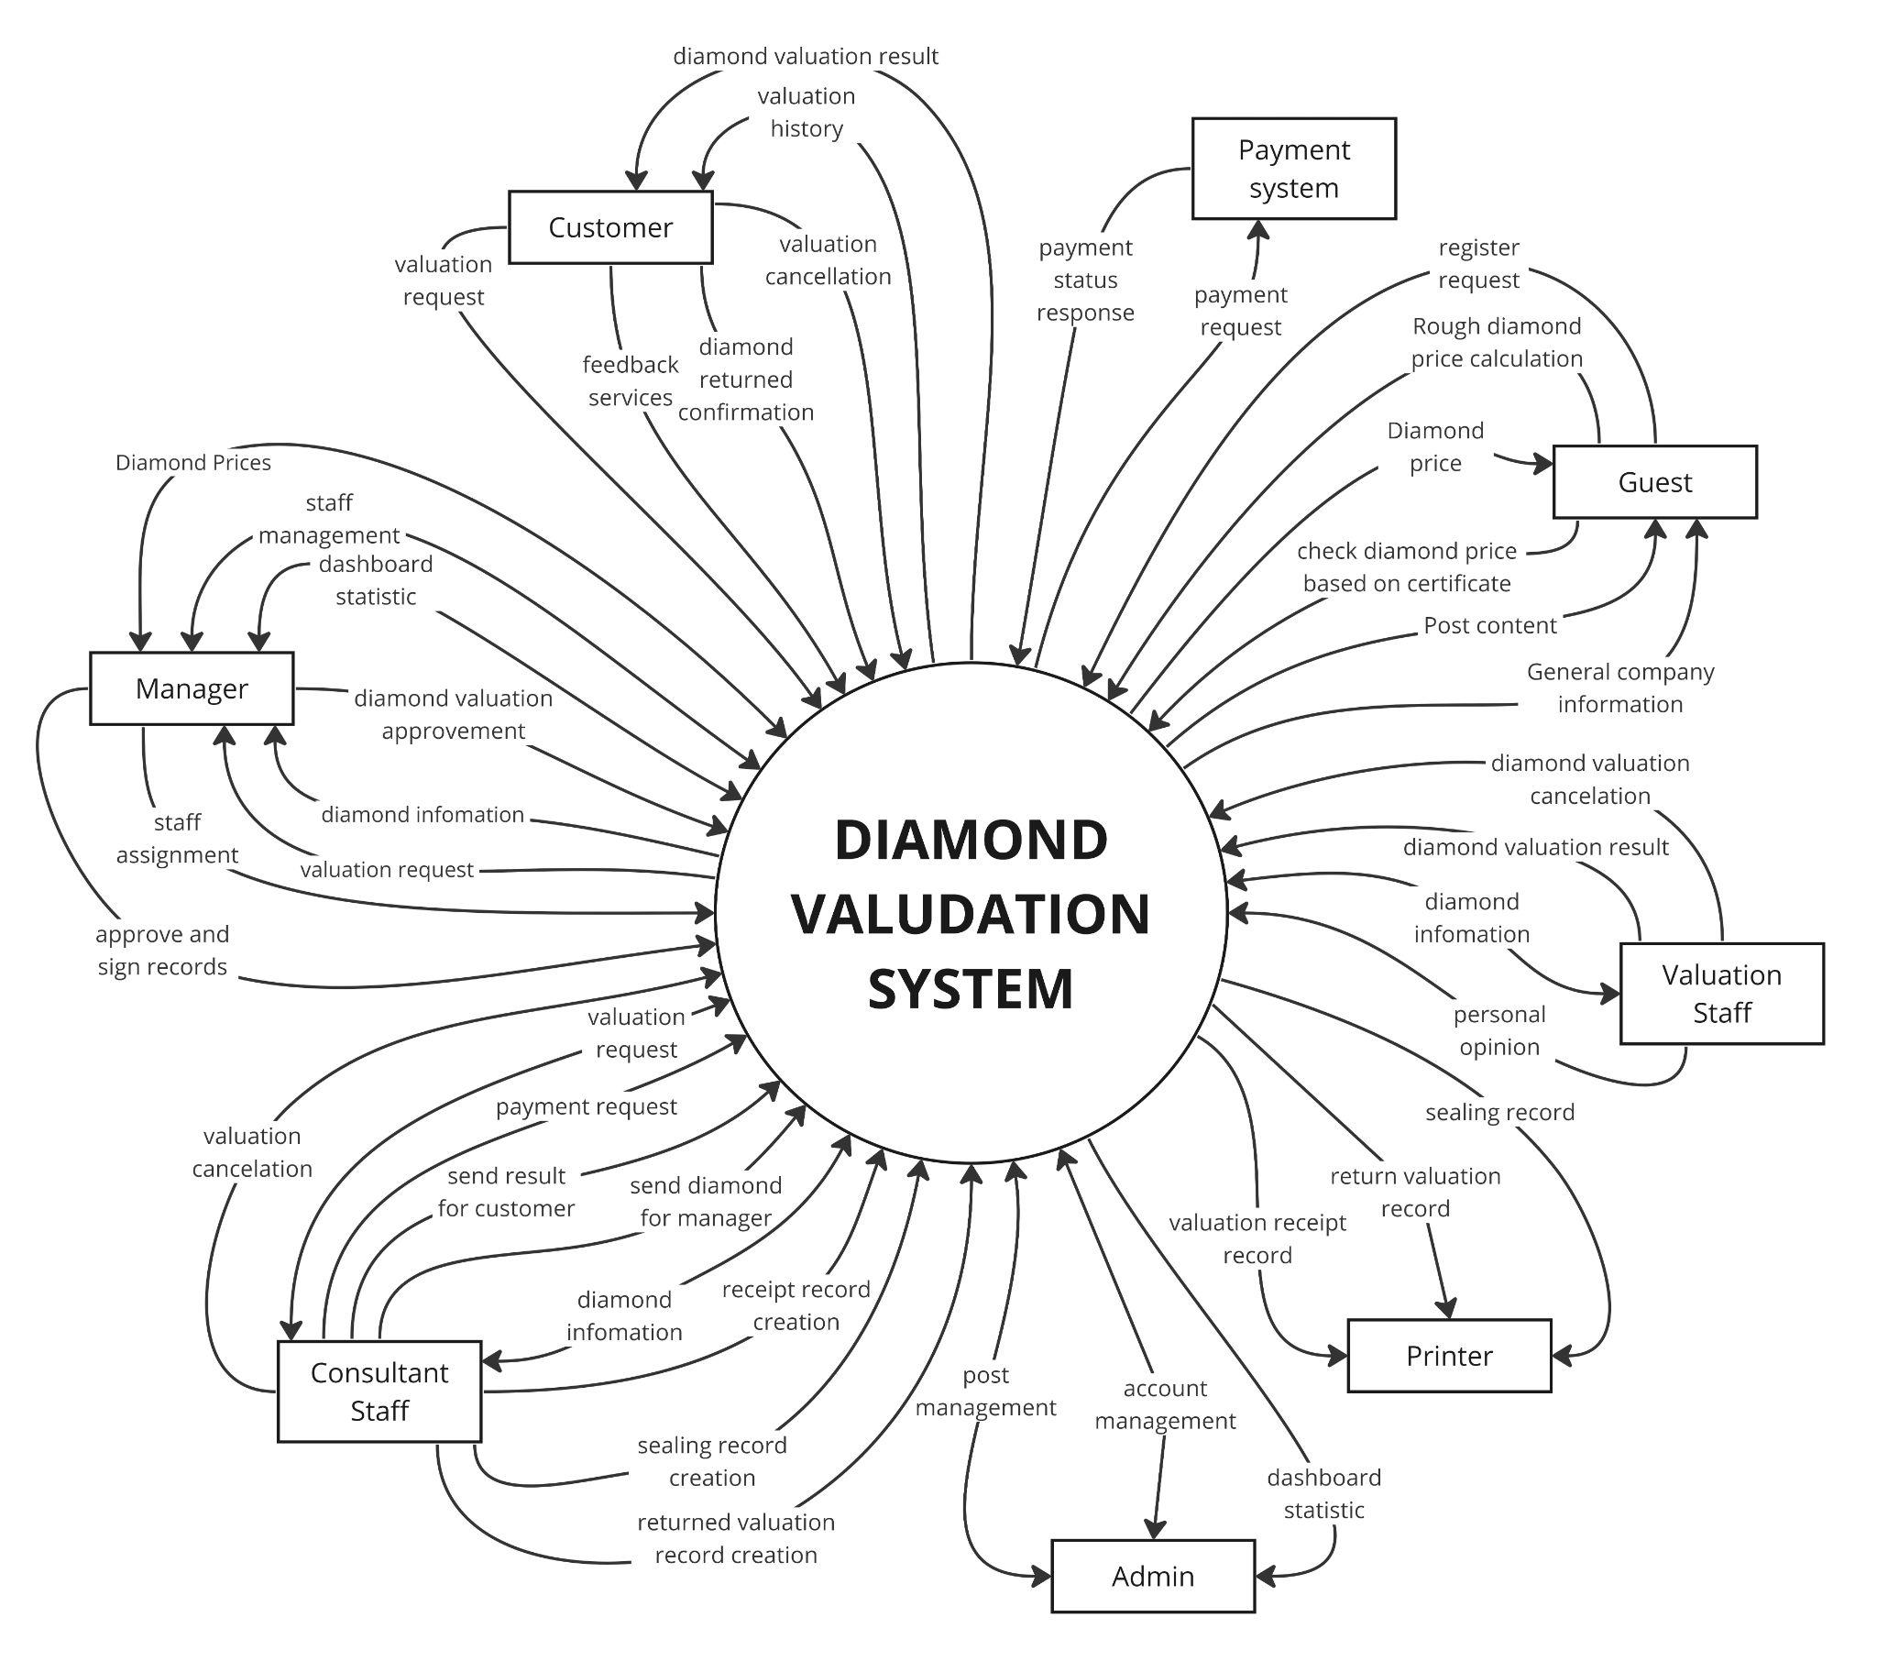

## 2. Existing Systems

### 2.1 PNJLab

* **Brief Description**: PNJ Lab is a division of Phu Nhuan Jewelry (PNJ), specialising in gemstone analysis and certification in Vietnam. The system uses modern technology and high expertise to assess the quality and authenticity of various gemstones and jewellery.
* **Website**:<https://pnjlab.com.vn/>
* **System Actors:**
* Customers
* Staff
* Administrators
* **Features**:
* Gemstone Analysis: Evaluation and quality determination of gemstones.
* Certification: Providing certification for inspected gemstone products.
* Consultation: Advising customers on gemstone products.
* **Pros:**
* Uses modern technology in gemstone analysis.
* Experienced and reputable experts.
* Provides trusted certifications ensuring product quality.
* **Cons**:
* High cost for inspection and certification.
* Services primarily focus on the Vietnamese market.
* **How this Informs "Diamond valuation management":**
* Use of modern technology and expert teams to ensure accurate assessments.
* Providing trusted certification to enhance product/service credibility.
* Detailed customer consultation to improve user experience.

### 2.2 StoneAlgo

* **Brief Description**: StoneAlgo is an online platform that provides a diamond price calculator to help users estimate the current retail price for diamonds. The system uses a comprehensive database of diamond prices from top-rated jewelers to offer accurate and up-to-date price estimates.
* **Website**:<https://www.stonealgo.com/diamond-price-calculator/>
* **System Actors:**
* Customers
* Administrators
* **Features:**
* Diamond Price Calculator: Estimates the retail price of diamonds based on various attributes like carat, colour, clarity, and cut.
* Price per Carat Calculation: Determines the price per carat for easier comparison between diamonds of different sizes.
* Market Trends: Provides insights into price changes and trends over the last 30 days.
* Certification Check: Allows users to verify diamond prices based on their certification details.
* **Pros:**
* Daily price updates from a vast database.
* User-friendly interface for easy price estimation.
* Provides comprehensive market insights and trends.
* **Cons:**
* Price estimates may vary significantly from actual market prices.

### How this Informs "Diamond valuation management":

### Allows users to enter specific parameters.

### Provides information about price trends and fluctuations

### Ensure user-friendly interface to improve user experience.

* Provides detailed certification and analysis to ensure transparency and trust

## 3. Business Process

| **#** | **Process Step** | **Description** |
| --- | --- | --- |
| 1 | Valuation request | The customer sends a valuation request with his/her information, amount of diamond and type of service to the system. |
| 2 | Assign Consultant staff | Manager receives customer valuation requests and assigns consultant staff to contact with customers who have the valuation request. |
| 3 | Contact with Customer to receive sample | The consultant receives customer information and contacts to receive sample(diamond) |
| 4 | Receive sample from Customer, create valuation receipt | After confirm sample submission, consultant staff will create valuation receipt include customer’s information, diamond receipt date, diamond return date, type of service, |
| 5 | Assign Valuation staff | Manager receives the confirm valuation and assigns valuation staff to valuate the diamond |
| 6 | Carry out diamond valuation | Valuation staff receive diamond’s information and proceed valuation (and may include assess diamond) and then send to the manager for consideration then if the manager approve |
| 7 | Approve the valuation | The manager receives three detailed diamond's valuations from three valuators. Then choose one of the best valuation to approval then send to consultant to return to customer |
| 8 | Send invoice & result | The consultant receives approval for the valuation from the manager and then sends results and invoice to the customer (soft copy) |
| 9 | Review and approve invoice | Customer receives and approves the soft copy of the valuation of his/her diamond including an invoice. |
| 10 | Send payment | Customers can choose to pay at the counter or pay via bank transfer. Customer must send payment when coming to |
| 11 | Receive payment | Consultant confirm the payment of customer |
| 12 | Print and return valuation | Consultant check the hard copy of the valuation receipt of the customer, if they have consultant will print and return the valuation to the customer |
| 13 | Receive valuation and receive his/her diamond | Customer receive valuation and receive his/her diamond |
| 14 | Create/Update  sealing record | If after appointment the customer doesn’t come to receive the valuation and his/her diamond the consultant will create the first sealing record with renewal date to receive (after 15 days) and sealing fee. Then send to the manager for consideration then if the manager approve  If after the first renewal date, the customer has not yet arrived to receive it, the consultant will update the renewal date and sealing fee. Then send to the manager for consideration then if the manager approve |
| 15 | Approve sealing record | The manager receives a sealing record for approval. |
| 16 | Notify for customer about sealing record | Consultant will contact to notify customer about sealing customer's diamond |
| 17 | Create a commitment about receiving the valuation | When a customer comes to receive his/her diamond but doesn't take the hard copy of the valuation receipt, consultant staff need to create a commitment about receiving the valuation. Then send to the manager for consideration then if the manager approve |
| 18 | Approve the commitment about receiving the valuation | The manager receives a sealing record for approval commitment about receiving the valuation and after that send back to consultant to consultant return the valuation and customer’s diamond to customer |

## 4. System Functions

#### a. Screen Flow

##### i. Customer Module

| **#** | **Feature** | **Screen** | **Description** |
| --- | --- | --- | --- |
| 1 | Account Management | User Login | Customer will enter their username and password to login. If the login attempt is unsuccessful, a "Username/Password is incorrect" message will be displayed. |
| 2 | Account Management | Forget password | Customer can retrieve a forgotten password via email or security questions. |
| 3 | Account Management | Register account | Customer creates a new account with required information. |
| 4 | Common | User’s home page | Provides something relevant to the service of the company and information about diamond (e.g.., current price of diamond, notifications). |
| 5 | Account Management | Profile | Contains customer’s account information (name, email, phone number, address,..) |
| 6 | Account management | Notification | Notificate to customer about the state of his/her appointment or about state of his/her diamond |
| 7 | Appointment management | Appointment | Display list of customer appointment with its state and information of its diamond. Customer also can cancel the appointment. |
| 8 | Account management | Payment | Display amount of payment that is total service price of diamonds, customer can choose payment by transfer |
| 9 | Appointment management | Appointment  Detail | Display details information of the appointment (owner, phone, appointment date, service,..) |
| 10 | Appointment management | Diamond Detail | Display details information of diamond which need to valuated |
| 11 | Appointment management | Service Rating | Customer can feedback to evaluate the service |
| 12 | Appointment | Appointment | Customer can make a appointment for check diamond valuation in store |
| 13 | Appointment | Appointment Detail | After customer press their personal information, they could see those information in detail |
| 14 | Common | About | Customer click About in navbar menu, About page show company information, service in detail |
| 15 | Common | Post | Post page show to customer all post which provide information and education about, update newest blog about diamond |
| 16 | Diamond Check | Diamond Check | Customer can insert their diamond GIA to check diamond price |
| 17 | Diamond Check | Diamond Result | After customer insert GIA, diamond result page show price of diamond |
| 18 | Calculation | Calculation | Customer choose field of diamond to check price in this page |
| 19 | Calculation | Calculation Result | After customer choose field of diamond, result page show price, and information about this diamond |

##### ii. Company Module

| **#** | **Feature** | **Screen** | **Description** |
| --- | --- | --- | --- |
| 1 | User Authentication | Login | The login screen allows users to enter their account information (email/username and password) to access the system. |
| 2 | Dashboard | Dashboard Information | Display an overview of information, a dashboard for a manager to monitor system activities. |
| 3 | Account Management | Update Profile | Update profile screen allows admin to update general information or change password |
| 4 | Valuation Request Management | Valuation Request | Display the list valuation request in this system as a table, each row will display basic information of each request. It filters by date creation, status. |
| 5 | Valuation Request Management | Valuation Request Detail | Display the detailed information of a request valuation, including information of customer, consultant staff and list diamonds in the request. |
| 6 | Valuation Request Management | Diamond detail | Display the detailed information of a diamond, including information of customer, valuation staffs and the price of diamond. |
| 7 | Record Management | Sealing Record | Display the list sealing record including information of diamond, customer and fee service. |
| 8 | Diamond Management | Diamond List | Display the list diamond including staff,customer,valuation processing |
| 9 | Diamond Management | Diamond Detail | Display the diamond in detail with each field(carat, origin, color, shape,.... ) |
| 10 | Service Management | Service List | Display the service list including information about service, service price |
| 11 | Service Management | Update Service | Update information about service |
| 12 | Price Management | Price | Company insert price for diamond with each field |
| 13 | Record Management | Receipt Record | Display the information of the customer and their diamond when sending the diamond to the company. It also display the signature of customer and manager for confirm the company receiving diamonds |
| 14 | Record Management | Returned record | Display returned record that are confirmed with both customer and manager for the diamond is returned, and the result is sent |
| 15 | Record Management | Invoice record | Display the information of invoice of customer payment |

##### iii. Admin Module

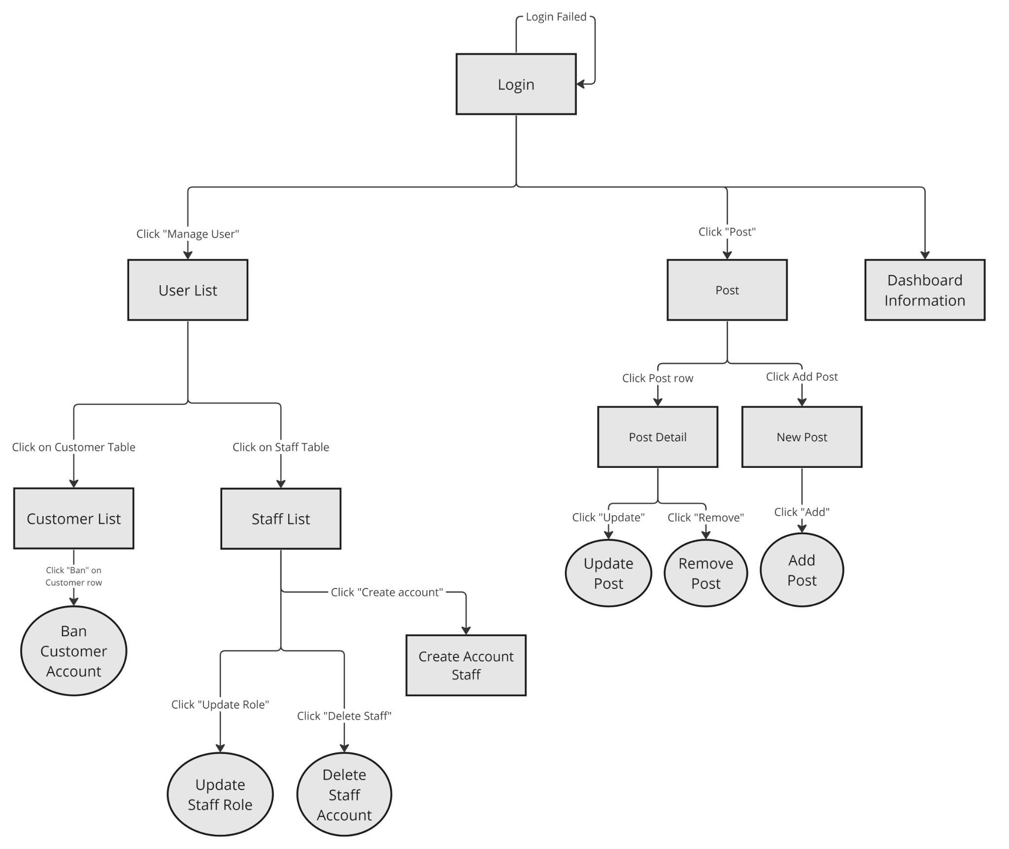

| **#** | **Feature** | **Screen** | **Description** |
| --- | --- | --- | --- |
| 1 | Account Management | Login | The login screen for administrators allows them to enter their account information (username and password) to access the administration system. If the login attempt is unsuccessful, a "Login Failed" message will be displayed. |
| 2 | Account Management | Update Profile | Update profile screen allows admin to update general information or change password |
| 3 | Dashboard | Dashboard Information | Display an overview of information, a dashboard for administrators to monitor system activities. |
| 4 | Post Management | All posts | Display all the posts in the system as a table list. It has tabs to filter post by status |
| 5 | Post Management | Detail post | Display post information in detail when clicking to each row in table post list |
| 6 | Post Management | New/Update post | Form screen for updating or creating new posts. |
| 7 | User Management | All User list | Display a list of all users in the system, including customers and staff members. Administrators can view details and lock customer accounts from this list. |
| 8 | User Management | Customer list | Display a list of all customers in the system. Administrators can view details and lock customer accounts. |
| 9 | User Management | Staff List | Display a list of all staff members in the system. Administrators can view details, create new accounts, update roles, and delete staff accounts. |
| 11 | User Management | New Staff | Form screen for create new staff account with new company email, username and password |

#### b. User Authorization

| **Screen** | **Guest** | **Customer** | **Consultant Staff** | **Valuation Staff** | **Manager** | **Admin** |
| --- | --- | --- | --- | --- | --- | --- |
| Login | X | X | X | X | X | X |
| Update Profile |  | X | X | X | X | X |
| Forget password |  | X | X | X | X | X |
| Dashboard |  |  |  |  | X | X |
| All posts | X | X |  |  |  | X |
| Detail post | X | X |  |  |  | X |
| New/Update post |  |  |  |  |  | X |
| All Users |  |  |  |  |  | X |
| Staff List |  |  |  |  | X | X |
| Customer List |  |  |  |  | X | X |
| New Staff |  |  |  |  |  | X |
| Receipt Record |  | X | X |  | X |  |
| Returned Record |  | X | X |  | X |  |
| Invoice Record |  | X | X |  |  |  |
| Valuation Request |  | X | X |  | X |  |
| Valuation Request Detail |  | X | X |  | X |  |
| Diamond detail |  | X | X | X | X |  |
| Sealing Record |  | X | X |  | X |  |
| Notification |  | X | X | X | X |  |
| Payment |  | X |  |  |  |  |
| Appointment |  | X |  |  |  |  |
| Appointment Detail |  | X |  |  |  |  |
| Service Rating |  | X |  |  |  |  |
| Diamond Check | X | X |  |  |  |  |
| Diamond Result | X | X |  |  |  |  |
| Calculation | X | X |  |  |  |  |
| Calculation Result | X | X |  |  |  |  |
|  |  |  |  |  |  |  |
|  |  |  |  |  |  |  |
|  |  |  |  |  |  |  |
|  |  |  |  |  |  |  |
|  |  |  |  |  |  |  |
|  |  |  |  |  |  |  |
|  |  |  |  |  |  |  |
|  |  |  |  |  |  |  |
|  |  |  |  |  |  |  |
|  |  |  |  |  |  |  |
|  |  |  |  |  |  |  |
|  |  |  |  |  |  |  |
|  |  |  |  |  |  |  |
|  |  |  |  |  |  |  |
|  |  |  |  |  |  |  |
|  |  |  |  |  |  |  |
|  |  |  |  |  |  |  |
|  |  |  |  |  |  |  |
|  |  |  |  |  |  |  |
|  |  |  |  |  |  |  |
|  |  |  |  |  |  |  |

## 5. Entity Relationship Diagram

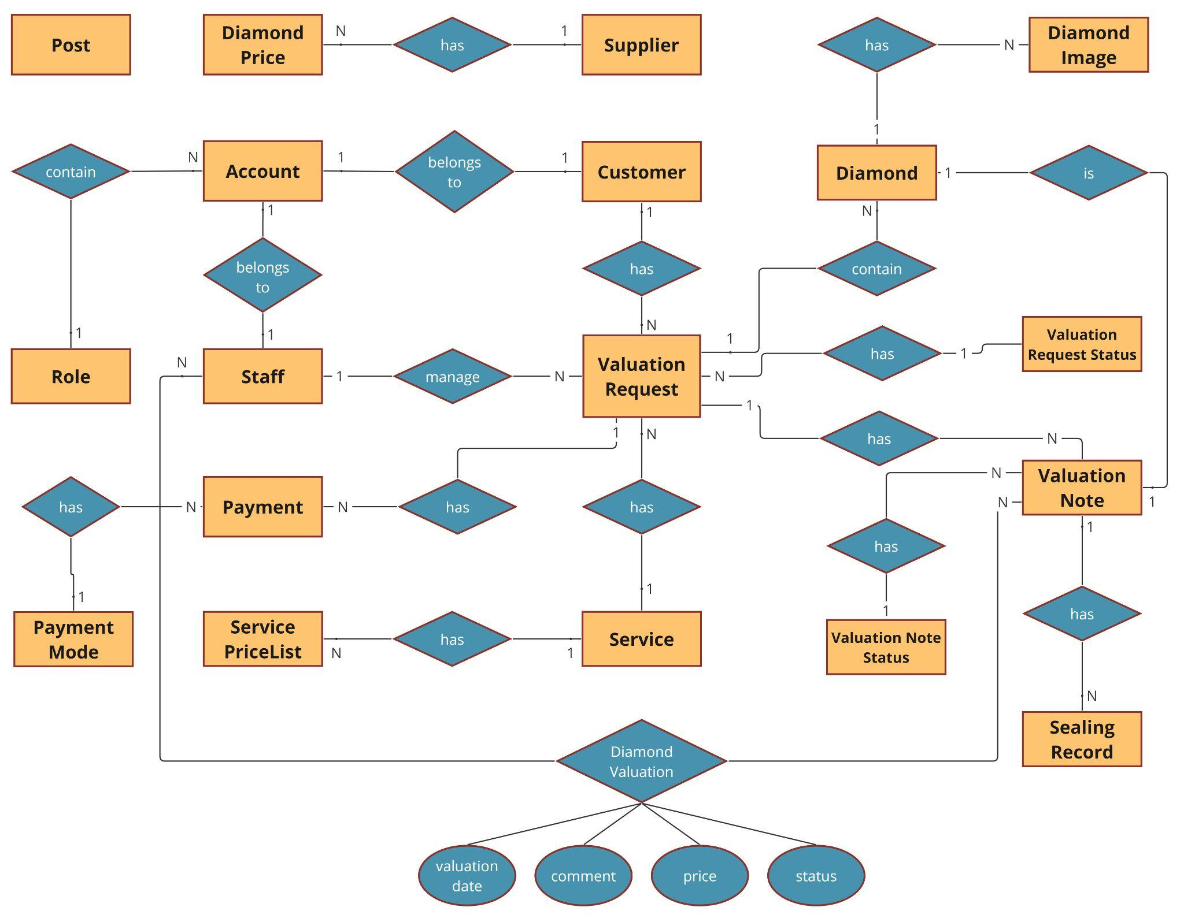

**Entities Description**

| **#** | **Entity** | **Description** |
| --- | --- | --- |
| 1 | Post | represent a the post of diamond, updating post of diamond price market |
| 2 | Diamond Price | store diamond price information. |
| 3 | Supplier | describe the supplier for each diamond |
| 4 | Account | represents all the account in the system |
| 5 | Staff | represent valuation staff, consultant staff, or manager account |
| 6 | Role | defines roles or authorities for account |
| 7 | Customer | describe customers in the system, customers may have multiple valuation and seal recording requirements. |
| 8 | Valuation Request | describe each diamond request of customer |
| 9 | Valuation Request Status | describe request status that gain from state transition diagram of valuation request |
| 10 | Service | describe the services of company |
| 11 | Service Price List | describe service for each type of diamond |
| 12 | Payment | represent the payment information |
| 13 | Payment Mode | represent the payment mode |
| 14 | Diamond | central entity with attributes such as Diamond Origin, Shape, Color, Clarity, Cut, Cut, Symmetry, Polish |
| 15 | Diamond Image | store images of diamond |
| 16 | Valuation Note | if the diamond is legal, the valuation note of diamond will be stored |
| 17 | Valuation Note Status | represent the valuation note status |
| 18 | Sealing Record | record information about diamond sealing and related information. |
| 19 | Diamond Valuation | describe the diamond valuation created by valuation staff |

## 6. State transition diagram

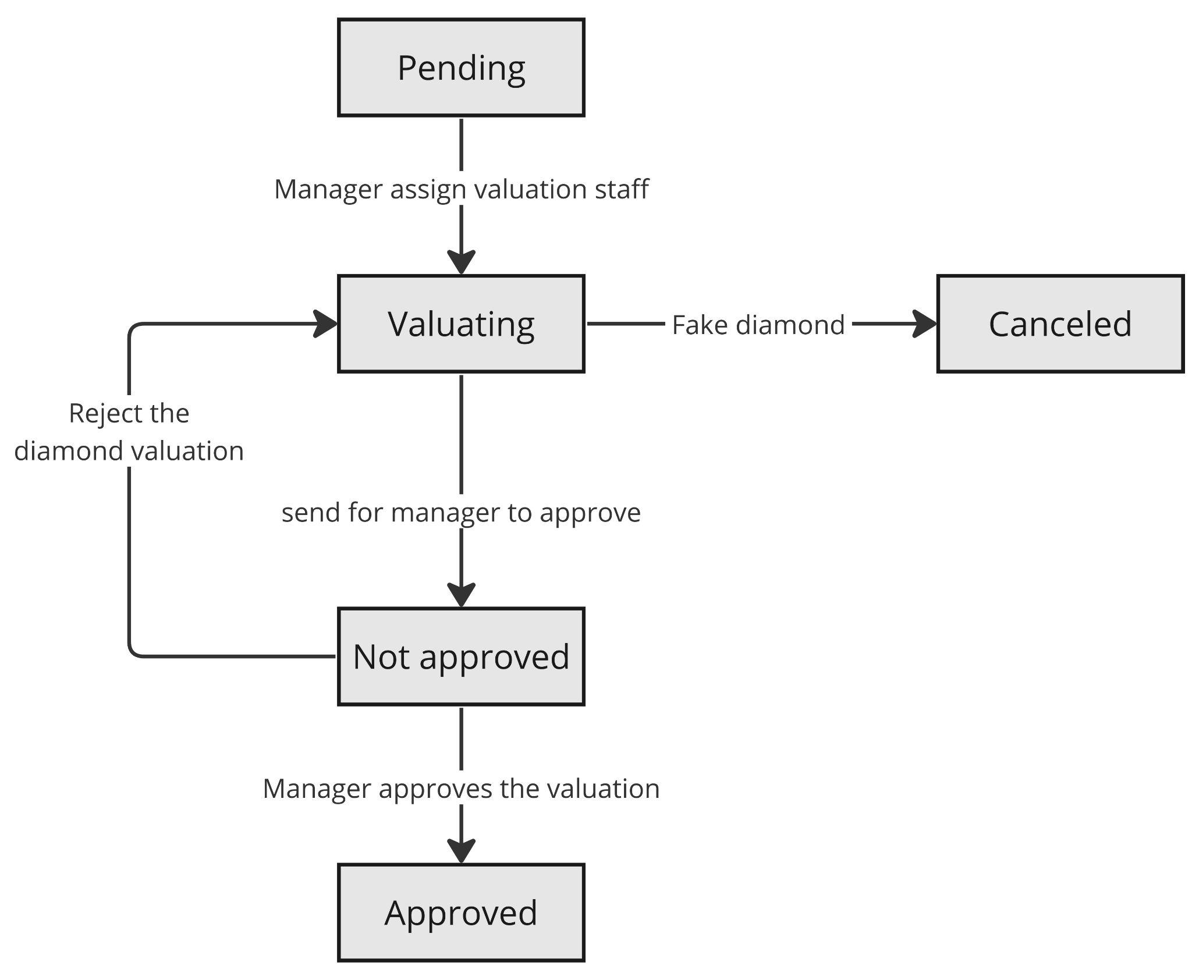

H6.1 *State transition diagram for Valuation Note*

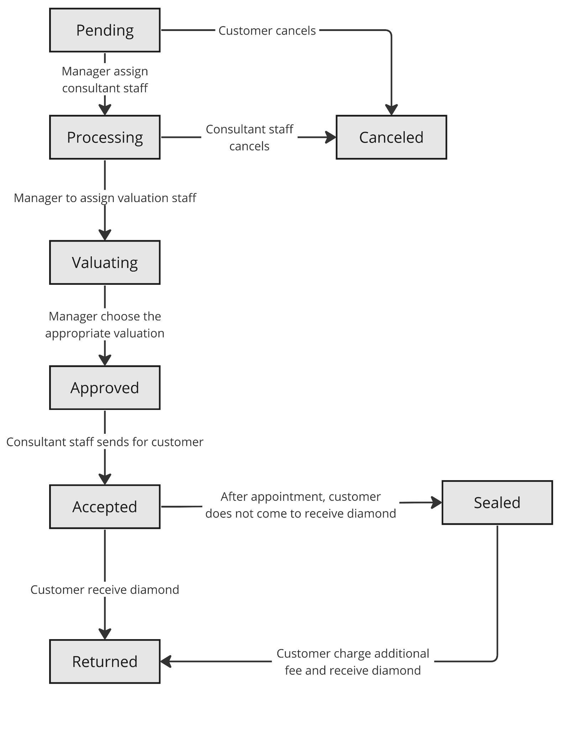  
H6.2 *State transition diagram for Valuation Request*

# II. Functional Requirements

## 1. <<Feature Name 1>>

### a. <<Function Name 1>>

*[A function can be a screen or a non-screen function (listed in the part I.2.d above). In this part, you need to provide the details on the related function, focus on mentioning below information*

* *Function trigger: how this function is triggered (navigation path, a timing frequency, etc.)*
* *Function description: actors/roles, purpose, interface, data processing, etc.*
* *Screen layout: mockup prototype of the screen, sample below is for Manage Products screen*

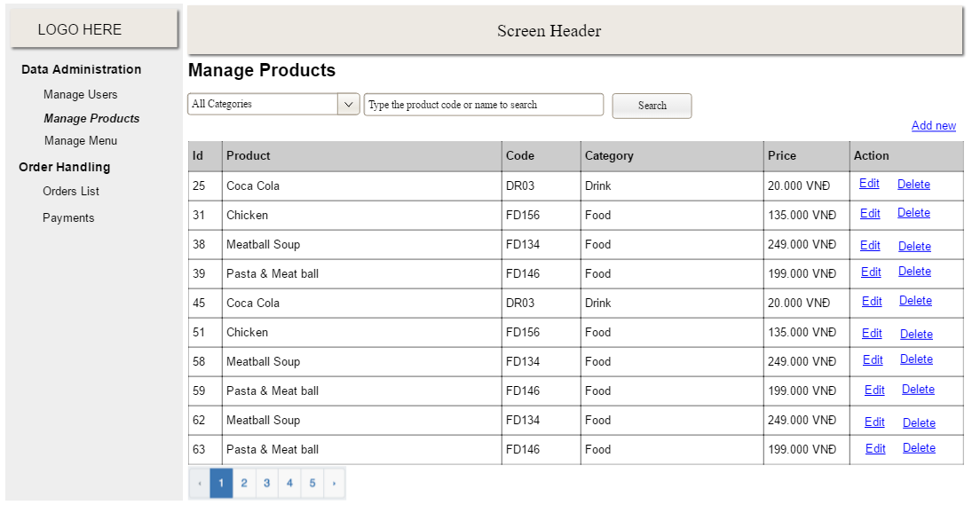

* *Function Details: provide explanation for the data, validation, business logics, functionalities (for both normal cases and abnormal cases), etc. of the function so that the reader can image how it work.*

*]*

*Customer & Guest*

Guest Home Page:

* Function trigger: Users access the homepage of the website.
* Function description: Display introductory content about the company, products/services in the form of photos and descriptive text.
* Screen layout: 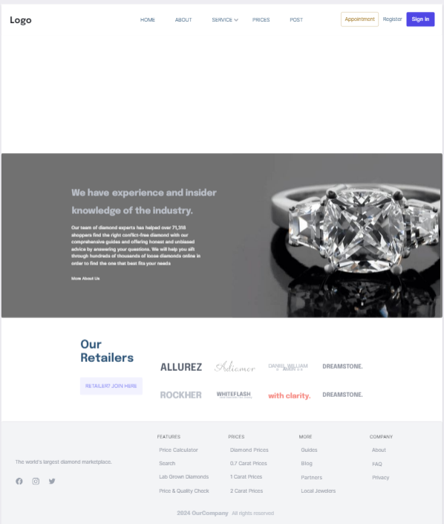
* Function detail: This function allows users to log in or register for an account

Guest Appointments Page:

* Function trigger: The user accesses the website and wants to schedule an appointment.
* Function description: Display a form that allows users to enter necessary information to schedule an appointment, such as name, phone number, email address, preferred time, appointment purpose, interested services, and other relevant details.
* Screen layout: 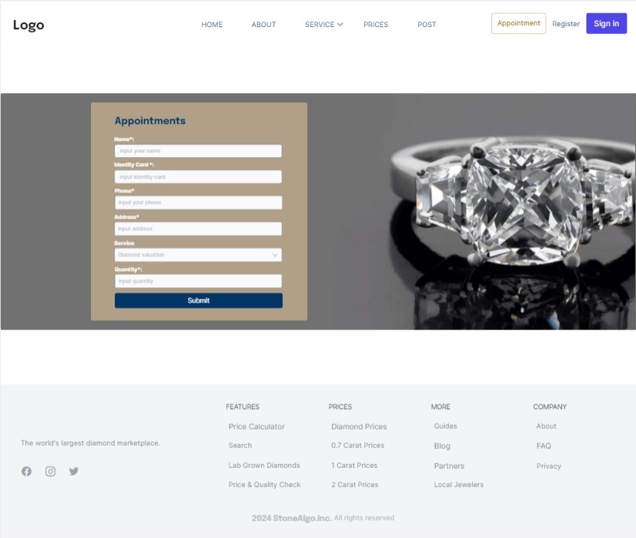
* Function detail: When the user fills in all the necessary information and clicks the "Submit" button, the appointment request will be sent. The registration details can be saved in a database or sent to the appointment management system. Afterwards, a staff member will review the request and contact the user to confirm and arrange the appointment.

Manage Account Welcome:

* Function trigger: User logs into the system , The navigation menu displays on the user interface
* Function description: Displays a welcome message with the username at the top of the interface after successful login.

Provide links for users to access key functions such as "Notifications", "Appointments", "Payment", "Settings".

* Screen layout: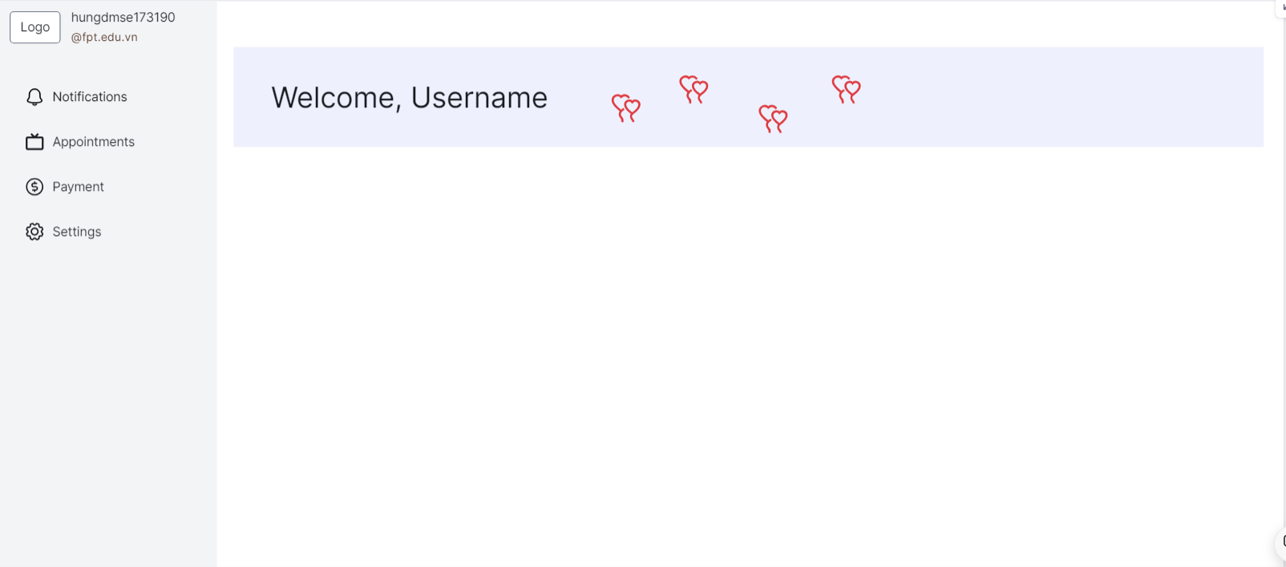
* Function detail: The system retrieves the user name information from the database or session, then displays it with a welcome message.

When the user clicks on a menu item, the system navigates to the corresponding page or interface to display information or allow related operations.

Sign up:

* Function trigger:New user visits the registration page and wants to create an account.
* Function description:Displays a form that allows users to enter personal information such as first name, last name, email, password, and confirm password to register a new account.
* Screen layout: 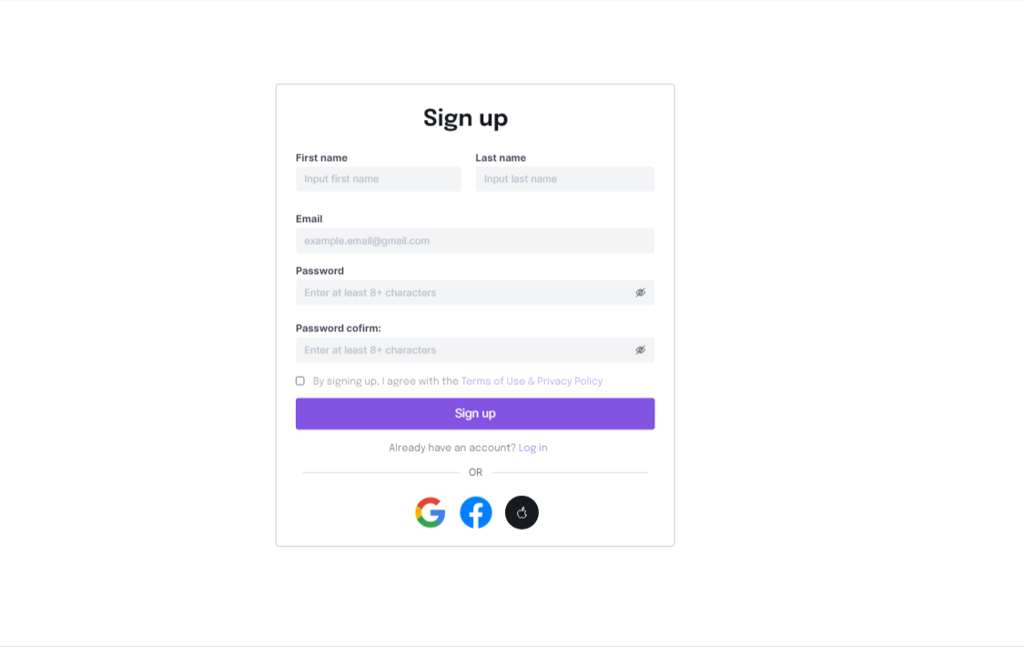
* Function detail:When the user enters all information and presses the "Sign up" button, the application will check the validity of the entered data (email format, password length,...). If the information is valid, the system will create a new account for the user. Then, the user can log in and use the application's functions with the newly registered account.

Guest Appointment Popup:

* Function trigger: Triggers when a user tries to make an appointment for a service on the website while not logged in
* Function description: This function is designed to handle appointment requests from users who want to use the services. It starts when a user fills out a booking form on the website.
* Screen layout: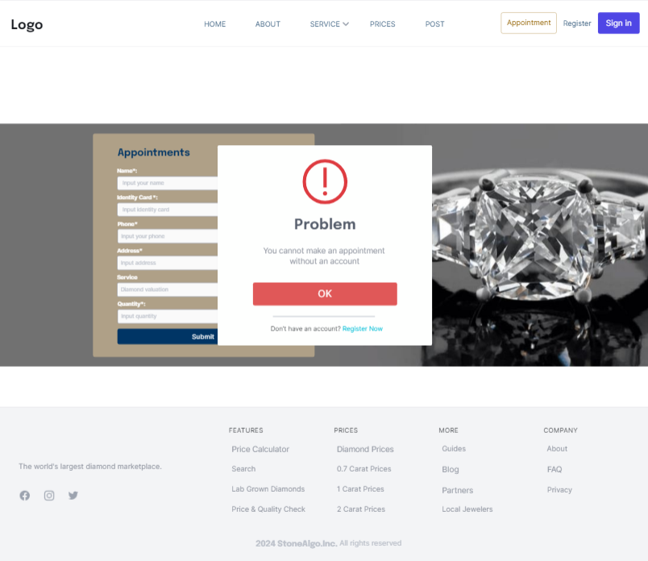
* Function detail: When the function is enabled, it displays an error message requiring the user to have an account to continue with the appointment booking. Below the notification, an "OK" button is provided for confirmation. Additionally, a call-to-action encourages users to sign up if they don't have an account yet. This helps guide users through the next steps to successfully schedule an appointment for their desired service.

Guest Appointment Popup:

* Function trigger:This function is activated after the user has successfully booked an appointment on the website.
* Function description:This function displays a confirmation message to the user once they have booked an appointment. The notification includes a green tick icon, the text "Awesome" and "Your booking has been confirmed," along with a button to close the confirmation notification.
* Screen layout: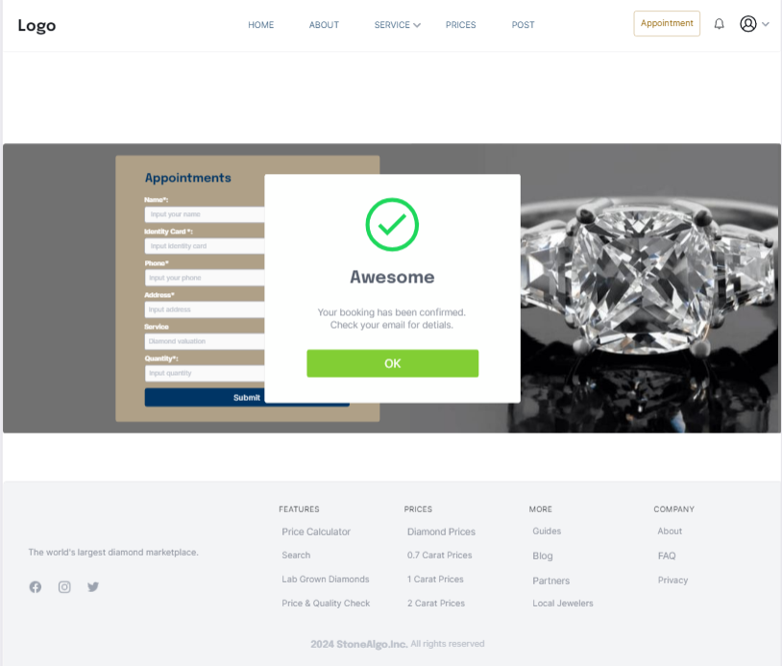
* Function detail: This function involves processing the user's appointment details, sending confirmation emails or messages. Normal cases will involve successful booking confirmation.

Diamond valuation customer:

* Function trigger: This function is activated when the user fills in the diamond's parameters and presses the "Submit" button on the calculation page.
* Function description: This function allows users to estimate a fair price for a diamond by entering the stone's characteristics into the calculator. It provides a tool to evaluate diamond value based on factors such as origin, carat, colour, clarity and cut quality.
* Screen layout: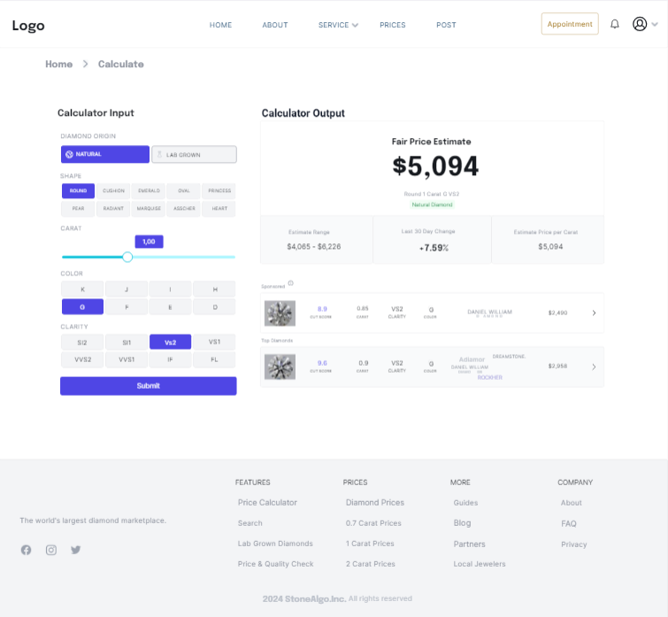
* Function detail: This function is responsible for gathering input from users about the diamond's characteristics, then uses a computational model to estimate a fair market value for that diamond.

This function also provides illustrations of the diamond's cut quality, cleanliness and proportions to help users better understand the factors that influence a diamond's value.

Manage Account Notifications:

* Function trigger: This function allows to manage user account notifications
* Function description: This function represents the notifications that are currently being sent to the user
* Screen layout: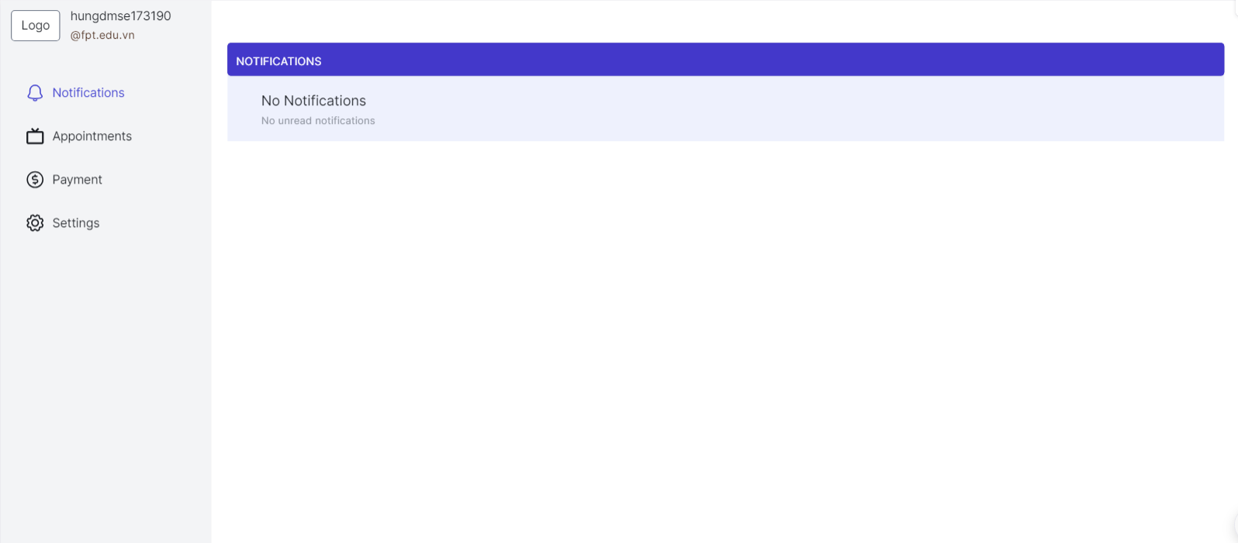
* Function detail: The navigation menu includes icons representing different sections such as Notifications, Appointments, Payments, and Settings. The main content area shows a title saying "notifications" and a message below it saying "No Notifications" with a subtitle saying there are no unread notifications.

Manage Account Appointment:

* Function trigger:This function is activated when the user clicks the "Cancel" button next to the appointment they want to cancel.
* Function description: This function allows users to cancel a previously scheduled appointment. When the "Cancel" button is pressed, a confirmation dialog box will be displayed for the user to reconfirm the appointment cancellation.
* Screen layout: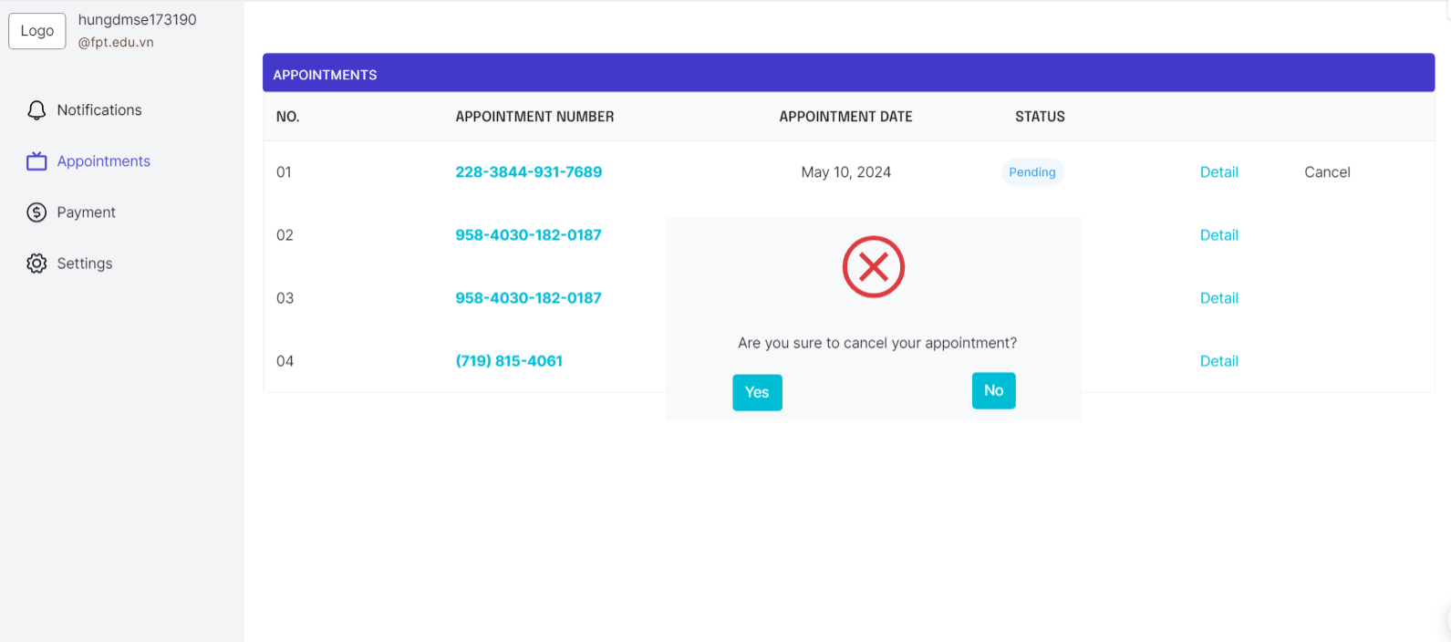
* Function detail: The interface displays a list of appointments with information such as order number, appointment number, appointment date and status (pending or completed). Each appointment has two buttons "Detail" and "Cancel". When clicking the "Cancel" button, a confirmation dialog box appears with the text "Are you sure to cancel your appointment?" (Are you sure you want to cancel your appointment?) and two buttons "Yes" and "No".

Login:

* Function trigger: The function describes the login screen user interface
* Function description: Display a form that allows users to enter email and password to log in to the system.
* Screen layout: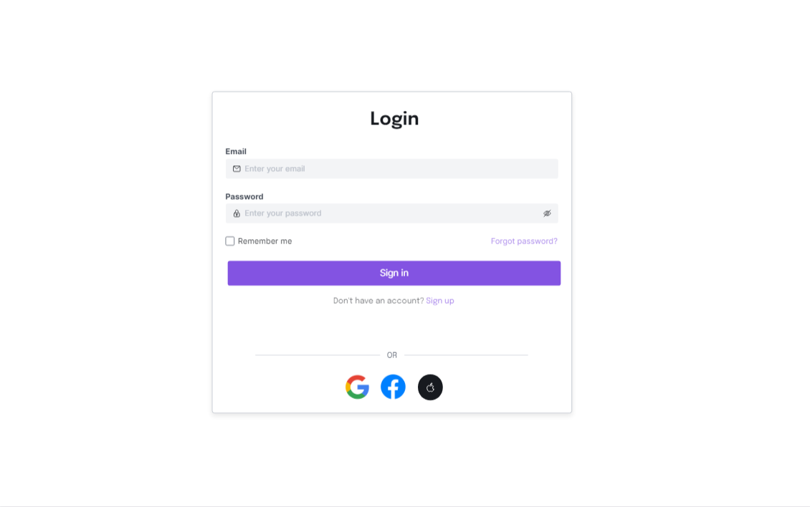
* Function detail: The function depicts a login screen user interface. The screen includes fields for entering an email address and password, as well as a "Remember me" checkbox. There is a button labeled "Sign in" to submit the login information. The interface also provides options for password recovery and creating a new account. Additionally, there are options to log in using Google and Facebook accounts.

Reset password:

* Function trigger: Triggers when a user forgets their password and needs to reset it.
* Function description: Users who have forgotten their passwords and need to reset them.To provide a simple and secure way for users to reset their passwords.
* Screen layout: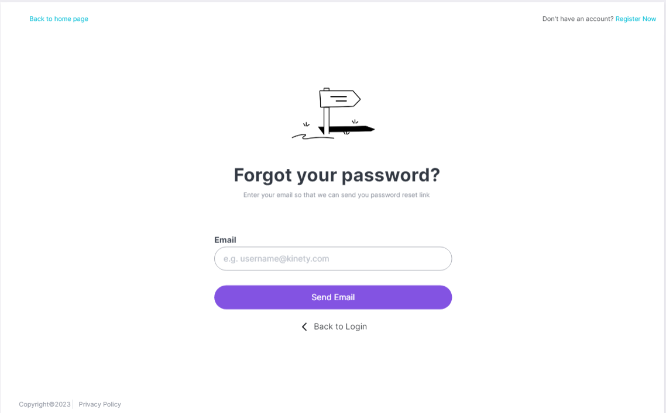
* Function detail: Collects and processes user-provided email addresses for sending password reset links. Ensures the email address format is correct before proceeding with the password reset. Allows users to initiate password reset, receive reset links via email, and return to the login page if needed.

Request Password:

* Function trigger: This screen is likely triggered when a user requests to reset their password.It may be accessed through a "Forgot Password" link or button on the login screen or through a password reset email link.
* Function description: The purpose of this screen is to allow users to set a new password for their account. It provides a secure way for users to regain access to their account by creating a new, strong password.
* Screen layout: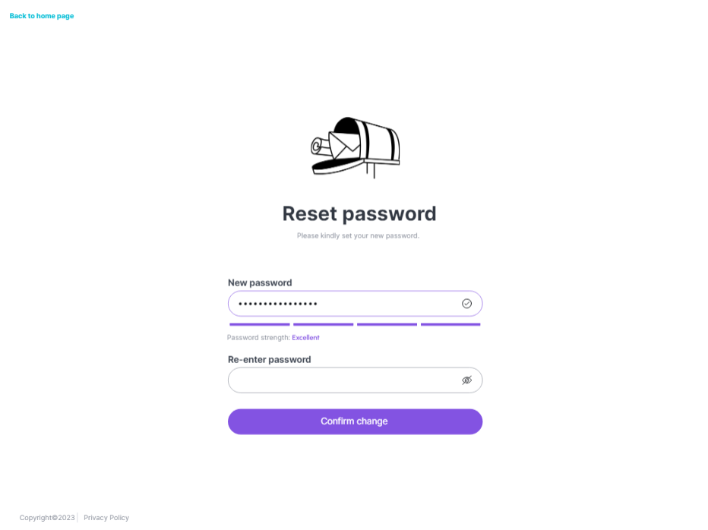
* Function detail:Password Reset: Once the user clicks the "Confirm change" button and the new password passes all validations, the application will update the user's account with the new password, effectively resetting their previous password.

Diamond valuation guest:

* Function trigger: The function allows guests to fill in the diamond's parameters and press the "Submit" button on the payment page
* Function description: This function allows guest to estimate a fair price for a diamond by entering the stone's characteristics into the calculator. It provides a tool to evaluate diamond value based on factors such as origin, carat, color, clarity and cut quality.
* Screen layout: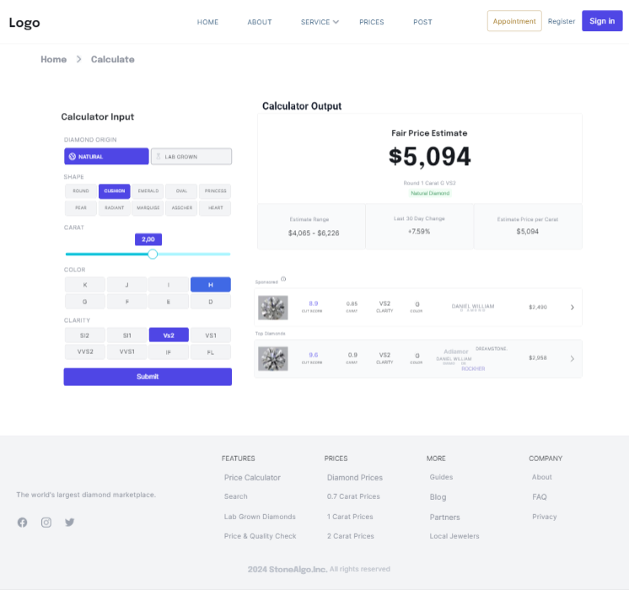
* Function detail: This function is responsible for gathering input from users about the diamond's characteristics, then uses a computational model to estimate a fair market value for that diamond.

This function also provides illustrations of the diamond's cut quality, cleanliness and proportions to help users better understand the factors that influence a diamond's value.

Appointment detail:

* Function trigger: This function is activated when users tap the "Detail" button next to the appointment they want to see details about.
* Function description: This function displays detailed information for a specific appointment, including information about the owner, phone number, appointment date, service, appointment date, as well as a list of diamonds associated with the appointment. those appointments and their status
* Screen layout: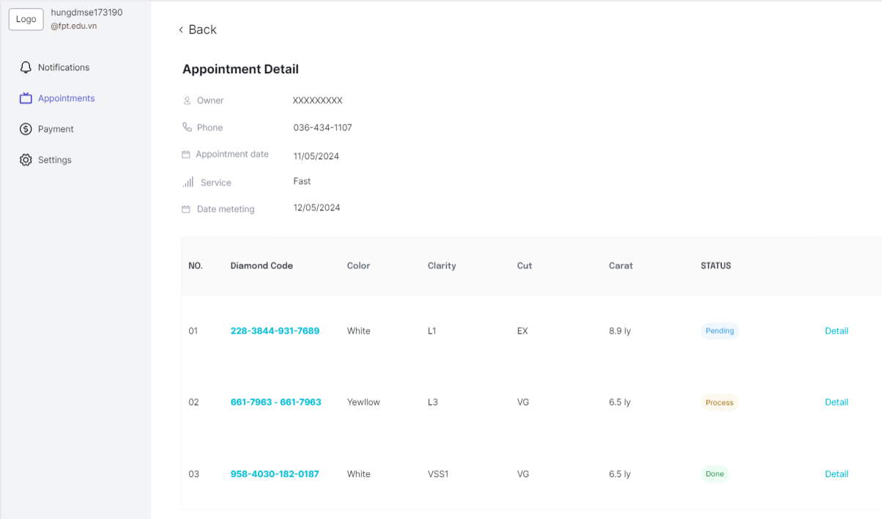
* Function detail:When the user clicks the "Detail" button, the function will retrieve detailed information of the appointment from the database or appointment management system. It displays basic appointment information such as owner, phone number, appointment date, service and appointment date. In addition, it also retrieves a list of diamonds related to that appointment and displays detailed information about each diamond such as diamond code, color, clarity, cut quality, carat and current state.

Manage account appointment:

* Function trigger:This function activates when the user needs to calculate and view the inspection results of a diamond after sending the diamond for inspection.
* Function description:This function allows users to view diamond inspection results, including parameters such as weight, color, clarity, cut grade and general assessment. The interface displays diamond photos, GIA certification and processing progress with steps from appointment to payment.
* Screen layout: 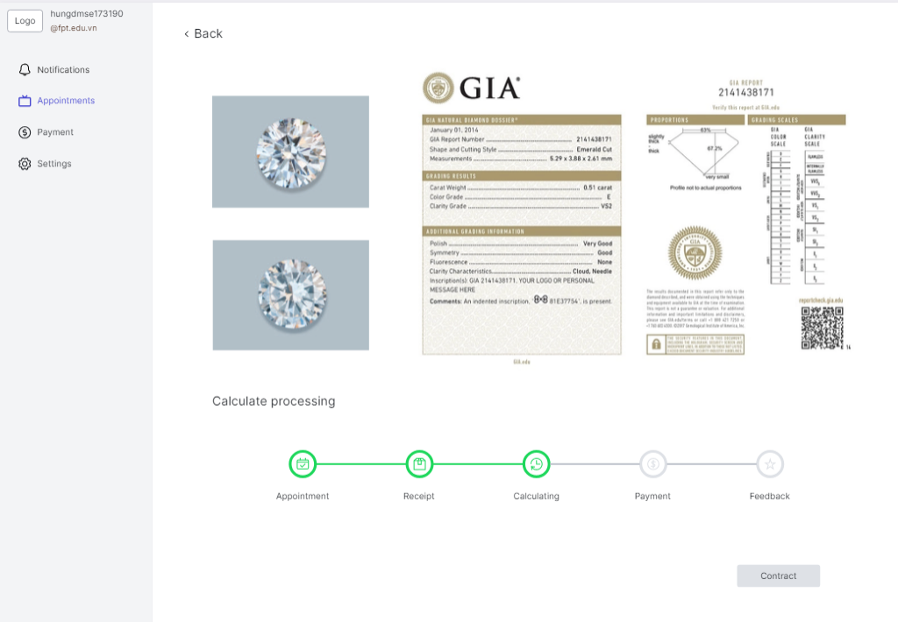
* Function detail: This function allows users to easily monitor the diamond inspection process. Data about the diamond is taken from the GIA certificate and presented clearly. The business logic includes verifying input data, calculating assessment results based on GIA standards, and providing a visual interface to display the results.

Guest diamond check:

* Function trigger: The diamond price and quality check function can be activated when the user enters the diamond certification number
* Function description:This function allows users to receive an estimate of the value and quality of the diamond based on the GIA certificate number. It provides detailed information on factors such as weight, color, clarity and cut quality to help users evaluate diamonds comprehensively.
* Screen layout: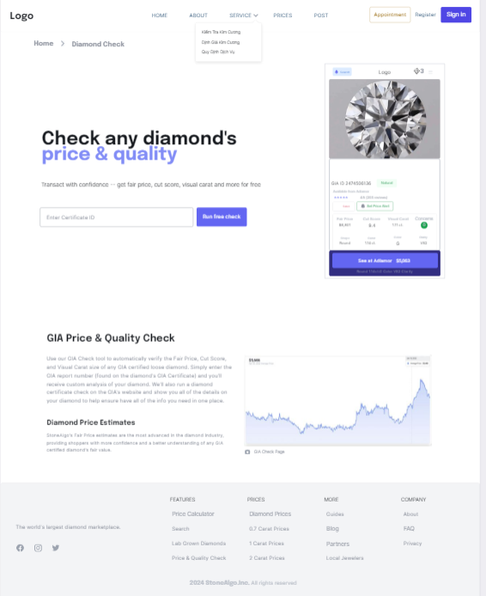
* Function detail:It uses business logic and calculation formulas to assess value based on weight, color, cleanliness, and cut quality. Results include value estimates, quality assessments, and additional information displayed visually on the interface. The data is also used to create price charts over time.

Guest About Page:

* Function trigger: It provides information about the company, their services, and what customers can expect.
* Function description:"About Us" page serves as an introduction to the company, highlighting their expertise, commitment to customer service, and showcasing their jewelry offerings.
* Screen layout: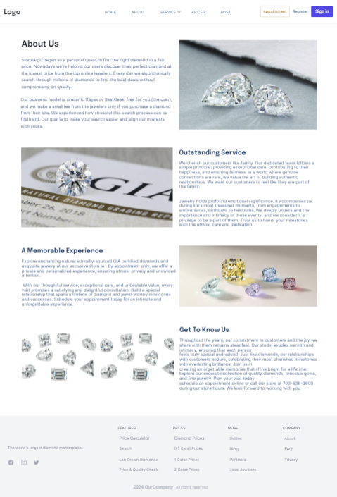
* Function detail:About Us: Describes the company's background and mission.Outstanding Service: Highlights the quality of service they provide to customers.A Memorable Experience: Emphasises creating a memorable experience for customers when purchasing jewelry.Get to Know Us: Provides contact information, location, and working hours.

Guest Post Page:

* Function trigger:This screen is likely triggered by navigating to the "Latest Posts" or blog section of the website, either through a menu or direct link
* Function description: Function description: The purpose of this section is to display the latest blog posts or articles related to diamonds, jewelry, and potentially advice or tips for customers. It provides information and insights to help users make informed decisions
* Screen layout: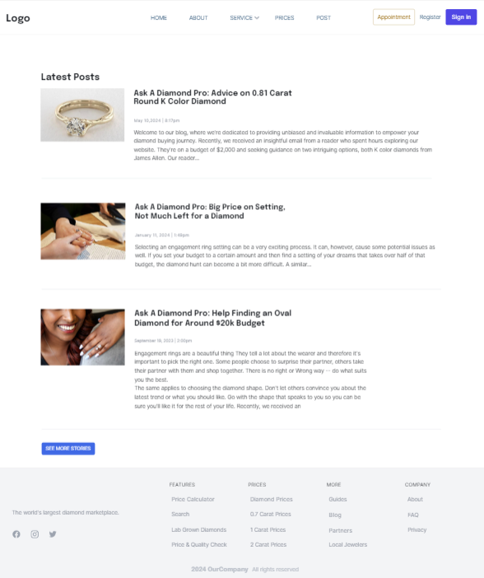
* Function detail:The primary function of this section is to showcase the most recent blog posts or articles created by the website or company. Each post entry typically includes an eye-catching image related to the topic, along with a compelling title and a brief summary or introduction to the post content.

### b. <<Function Name 2>>

…

## 2. <<Feature Name 2>>

…

# III. Database Design

## 1. Database Schema

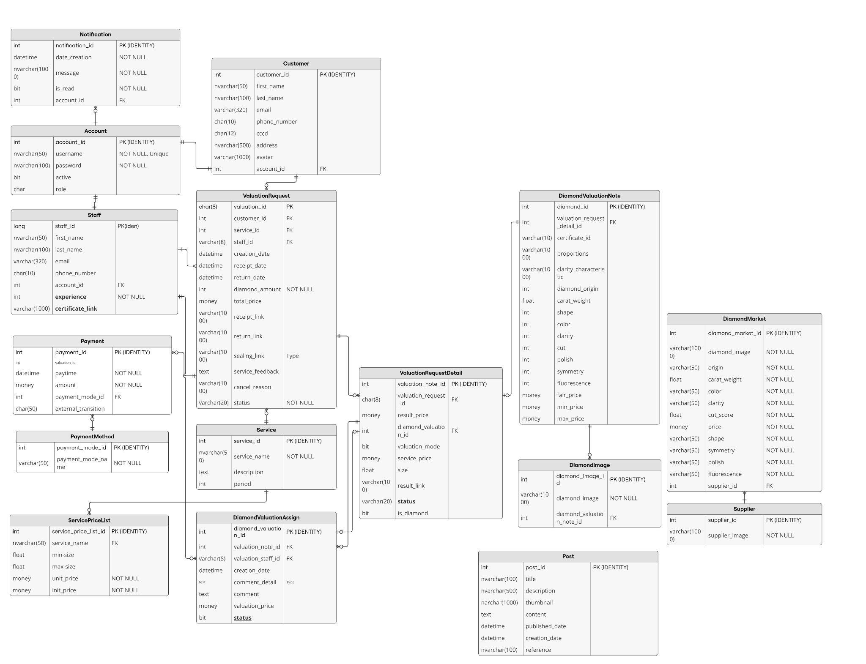

**Table Description**

| **No** | **Table** | **Description** |
| --- | --- | --- |
| 1 | Post | * This table stores information about blog posts or articles. * **Fields**:   + **post_id** (PK): Unique identifier for each post.   + **title**: The title of the post.   + **description**: A brief description or summary of the post.   + **thumbnail**: URL or path to the thumbnail image of the post.   + **content**: The main content of the post.   + **published_date**: The date and time when the post was published.   + **creation_date**: The date and time when the post was created.   + **reference**: A reference or link to additional resources or related posts |
| 2 | DiamondPrice | * Stores pricing information for diamonds. * **Fields**:   + **price_id** (PK): Unique identifier for each price record.   + **creation_date**: Date and time when the price record was created.   + **origin**, **shape**, **color**, **clarity**, **cut**, **carat_weight,** **polish**, **symmetry**, **fluorescence**: Various attributes affecting the diamond's price.   + **fair_price**, **min_price**, **max_price**: Different price points for the diamond.   + **supplier_id**(FK): Identifier for the supplier of the diamond. * **Relationships**: Connected to  **Supplier** tables. |
| 3 | Supplier | * Stores information about suppliers who provide diamonds * **Fields**:   + **supplier_id** (PK): Unique identifier for each supplier.   + **supplier_name**: Supplier name.   + **supplier_icon**: Supplier icon. * **Relationships**: Connected to  **DiamondPrice** tables. |
| 4 | Account | * Stores user account information. * **Fields**:   + **account_id** (PK): Unique identifier for each account.   + **username**: The user's login name.   + **password**: The user's password.   + **active**: Status indicating whether the account is active.   + **role_id** (FK): Role assigned to the account. * **Relationships**: Connected to **Role** and **Staff** tables. |
| 5 | Customer | * Stores information about customers. * **Fields**:   + **customer_id** (PK): Unique identifier for each customer.   + **first_name**: Customer’s first name   + **last_name**: Customer’s last name   + **email**: Customer’s email   + **phone**: Customer’s phone   + **avatar**: Customer’s avatar   + **identity_document**: Customer's identification number.   + **address**: Customer's address.   + **account_id** (FK): Links to the **Account** table. * **Relationships**: Connected to **Account** table. |
| 6 | Staff | * Stores information about staff members. * **Fields**:   + **staff_id** (PK): Unique identifier for each staff member.   + **account_id** (FK): Links to the **Account** table.   + **first_name**, **last_name**: Staff member's name.   + **email**, **phone_number**: Contact information.   + **status**: Employment status.   + **experience**: Number of years of experience.   + **certificate_link**: URL or path to certification documents * **Relationships**: Linked to **Account** table for login credentials. |
| 7 | Role | * Defines roles for user accounts. * **Fields**:   + **role_id** (PK): Unique identifier for each role.   + **role_name**: Name of the role.   + **role_description**: Description of the role. * **Relationships**: Linked to the **Account** table. |
| 8 | ValuationRequest | * Records requests for diamond valuations. * **Fields**:   + **valuation_id** (PK): Unique identifier for each valuation request.   + **customer_id** (FK): Links to the **Customer** table.   + **service_id** (FK): Links to the **Service** table.   + **consultant_staff_id** (FK): Links to the **Staff** table.   + **creation_date**, **receipt_date**, **return_date**: Dates related to the valuation process.   + **diamond_amount**: Number of diamonds in the request.   + **status**: Current status of the request.   + **total_price**: Total price of the valuation.   + **receipt_link**, **return_link**: URLs or paths to related documents.   + **service_feedback**: Feedback from the customer about the service.   + **payment_id** (FK): Links to the **Payment** table. * **Relationships**: Connected to **Customer**, **Service**, **Staff**, and **Payment** tables. |
| 9 | Payment | * Records payment transactions. * **Fields**:   + **payment_id** (PK): Unique identifier for each payment.   + **paytime**: Date and time of payment.   + **amount**: Amount paid.   + **payment_mode_id** (FK): Payment mode used.   + **external_transition**: External transaction ID. |
| 10 | PaymentMode | * Defines different payment modes * **Fields**:   + **payment_mode_id** (PK): Unique identifier for each payment mode.   + **payment_mode_name**: Name of the payment mode. * **Relationships**: Linked to **Payment** table. |
| 11 | ValuationRequestStatus | * Defines the status of valuation requests. * **Fields**:   + **valuation_request_status_id** (PK): Unique identifier for each status.   + **valuation_request_status_name**: Name of the status. * **Relationships**: Linked to **ValuationRequest**. |
| 12 | ValuationNote | * Stores notes related to diamond valuations. * **Fields**:   + **valuation_note_id** (PK): Unique identifier for each note.   + **diamond_id** (FK): Links to the **Diamond** table.   + **result_price**: Price resulting from the valuation.   + **diamond_valuation_id** (FK): Links to the **DiamondValuation** table.   + **valuation_mode**: Mode of the valuation.   + **sealing_record_id** (FK): Links to the **SealingRecord** table.   + **sealing_record_link**: URL or path to the sealing record. * **Relationships**: Linked to **Diamond**, **DiamondValuation**, and **SealingRecord** tables. |
| 13 | Service | * Defines various services offered. * **Fields**:   + **service_id** (PK): Unique identifier for each service.   + **service_name**: Name of the service.   + **description**: Description of the service.   + **period**: Duration of the service. * **Relationships**: Linked to **ValuationRequest** table. |
| 14 | ServicePriceList | * Defines services price list offered. * **Fields**:   + **service_price_list_id** (PK): Unique identifier for each service price list.   + **service_name**: Name of the service.   + **min-size**: Min-size of service price.   + **max-size**: Max-size of service price.   + **period**: Duration of the service. * **Relationships**: Linked to **Service** table. |
| 15 | DiamondValuation | * Records valuations performed on diamonds. * **Fields**:   + **diamond_valuation_id** (PK): Unique identifier for each valuation.   + **diamond_id** (FK): Links to the **Diamond** table.   + **valuation_staff_id** (FK): Links to the **Staff** table.   + **creation_date**: Date and time of the valuation.   + **comment**: Comments about the valuation.   + **valuation_price**: Price determined by the valuation.   + **status**: Status of the valuation. * **Relationships**: Linked to **Diamond** and **Staff** tables. |
| 16 | DiamondValuationStatus | * Defines the status of diamond valuations. * **Fields**:   + **diamond_valuation_status_id** (PK): Unique identifier for each status.   + **diamond_valuation_status_name**: Name of the status. * **Relationships**: Linked to **DiamondValuation** table. |
| 17 | SealingRecord | * Stores records of diamond sealing processes. * **Fields**:   + **sealing_record_id** (PK): Unique identifier for each sealing record.   + **creation_date**: Date and time of the sealing.   + **sealing_price**: Cost of the sealing process.   + **status**: Status of the sealing record. * **Relationships**: Linked to **Diamond** table. |
| 18 | Diamond | * Stores detailed information about diamonds. * **Fields**:   + **diamond_id** (PK): Unique identifier for each diamond.   + **valuation_id** (FK): Links to the **ValuationRequest** table.   + **certificate_id**: Certificate identifier for the diamond.   + **proportions**, **clarity_characteristic**: Physical characteristics of the diamond.   + **diamond_origin**: Origin of diamond   + **carat_weight**: Weight of the diamond.   + **shape**, **color**, **clarity**, **cut**, **polish**, **symmetry**, **fluorescence**: Various attributes of the diamond.   + **fair_price**, **min_price**, **max_price**: Pricing details.   + **diamond_status:** Status of diamond * **Relationships**: Connected to **ValuationRequest**, and **ValuationNote** tables. |
| 19 | DiamondImage | * Stores images of diamonds * **Fields**:   + **diamond_image_id** (PK): Unique identifier for each image.   + **diamond_image**: URL or path to the image.   + **diamond_id** (FK): Links to the **Diamond** table.   **Relationships**: Linked to **Diamond** table. |

## 2. Table Detail

| **Post** | | | | | | | |
| --- | --- | --- | --- | --- | --- | --- | --- |
| **#** | **Field name** | **Type** | **Size** | **Unique** | **Not Null** | **PK/FK** | **Notes** |
| 1 | post_id | int |  |  |  | PK |  |
| 2 | title | nvarchar | 2-100 |  |  |  |  |
| 3 | description | nvarchar | 2-500 |  |  |  |  |
| 4 | thumbnail | nvarchar | 2-1000 |  |  |  |  |
| 5 | content | text |  |  |  |  |  |
| 6 | published_date | datetime |  |  |  |  |  |
| 7 | creation_date | datetime |  |  |  |  |  |
| 8 | reference | nvarchar | 2-100 |  |  |  |  |

| **DiamondPrice** | | | | | | | |
| --- | --- | --- | --- | --- | --- | --- | --- |
| **#** | **Field name** | **Type** | **Size** | **Unique** | **Not Null** | **PK/FK** | **Notes** |
| 1 | price_id | int |  |  |  | PK |  |
| 2 | creation_date | datetime |  |  | X |  |  |
| 3 | origin | varchar | 2-50 |  | X |  |  |
| 4 | shape | varchar | 2-50 |  | X |  |  |
| 5 | carat_weight | float | 0.25-5 |  | X |  |  |
| 6 | color | varchar | 2-50 |  | X |  |  |
| 7 | clarity | varchar | 2-50 |  | X |  |  |
| 8 | cut | varchar | 2-50 |  | X |  |  |
| 9 | polish | varchar | 2-50 |  | X |  |  |
| 10 | symmetry | varchar | 2-50 |  | X |  |  |
| 11 | fluorescence | varchar | 2-50 |  | X |  |  |
| 12 | fair_price | money |  |  | X |  |  |
| 13 | min_price | money |  |  | X |  |  |
| 14 | max_price | money |  |  | X |  |  |
| 15 | supplier_id | varchar | 2-50 |  | X |  |  |

| **Supplier** | | | | | | | |
| --- | --- | --- | --- | --- | --- | --- | --- |
| **#** | **Field name** | **Type** | **Size** | **Unique** | **Not Null** | **PK/FK** | **Notes** |
| 1 | supplier_id | int |  |  |  | PK |  |
| 2 | supplier_name | nvarchar | 2-50 |  | X |  |  |
| 3 | supplier_icon | nvarchar | 2-1000 |  |  |  |  |

| **Account** | | | | | | | |
| --- | --- | --- | --- | --- | --- | --- | --- |
| **#** | **Field name** | **Type** | **Size** | **Unique** | **Not Null** | **PK/FK** | **Notes** |
| 1 | account_id | int |  |  |  | PK |  |
| 2 | username | nvarchar | 2-50 | X | X |  |  |
| 3 | password | nvarchar | 2-100 |  | X |  |  |
| 4 | email | nvarchar | 2-320 |  | X |  |  |
| 5 | active | nvarchar | 10 |  | X |  |  |
| 6 | role_id | int |  |  |  | FK |  |

| **Staff** | | | | | | | |
| --- | --- | --- | --- | --- | --- | --- | --- |
| **#** | **Field name** | **Type** | **Size** | **Unique** | **Not Null** | **PK/FK** | **Notes** |
| 1 | staff_id | char | 8 |  |  | PK |  |
| 2 | account_id | int |  |  |  | FK |  |
| 3 | first_name | nvarchar | 2-20 |  |  |  |  |
| 4 | last_name | nvarchar | 2-50 |  |  |  |  |
| 5 | email | nvarchar | 2-320 |  |  |  |  |
| 6 | phone_number | char | 10 |  |  |  |  |
| 7 | status | bit |  |  | X |  |  |
| 8 | experience | int |  |  | X |  |  |
| 9 | certificate_link | nvarchar | 2-1000 |  |  |  |  |

| **Role** | | | | | | | |
| --- | --- | --- | --- | --- | --- | --- | --- |
| **#** | **Field name** | **Type** | **Size** | **Unique** | **Not Null** | **PK/FK** | **Notes** |
| 1 | role_id | int |  |  |  | PK |  |
| 2 | role_name | nvarchar | 2-20 |  | X |  |  |
| 3 | role_description | nvarchar | 2-100 |  |  |  |  |

| **Customer** | | | | | | | |
| --- | --- | --- | --- | --- | --- | --- | --- |
| **#** | **Field name** | **Type** | **Size** | **Unique** | **Not Null** | **PK/FK** | **Notes** |
| 1 | customer_id | int |  |  |  | PK |  |
| 2 | identity_document | nvarchar | 50 | X | X |  |  |
| 3 | address | nvarchar | 500 |  |  |  |  |
| 4 | account_id | int |  |  |  | FK |  |
| 5 | avatar | nvarchar | 500 |  |  |  |  |
| 6 | first_name | nvarchar | 50 |  | X |  |  |
| 7 | last_name | nvarchar | 50 |  | X |  |  |
| 8 | email | varchar | 100 |  | X |  |  |
| 9 | phone | char | 20 |  | X |  |  |

| **Payment** | | | | | | | |
| --- | --- | --- | --- | --- | --- | --- | --- |
| **#** | **Field name** | **Type** | **Size** | **Unique** | **Not Null** | **PK/FK** | **Notes** |
| 1 | payment_id | int |  |  |  | PK |  |
| 2 | paytime | datetime |  |  | X |  |  |
| 3 | amount | money |  |  | X |  |  |
| 4 | payment_mode_id | int |  |  |  | FK |  |
| 5 | external_transition | char | 2-50 |  |  |  |  |

| **PaymentMode** | | | | | | | |
| --- | --- | --- | --- | --- | --- | --- | --- |
| **#** | **Field name** | **Type** | **Size** | **Unique** | **Not Null** | **PK/FK** | **Notes** |
| 1 | payment_mode_id | int |  |  |  | PK |  |
| 2 | payment_mode_name | varchar | 2-50 |  | X |  |  |

| **ValuationRequestStatus** | | | | | | | |
| --- | --- | --- | --- | --- | --- | --- | --- |
| **#** | **Field name** | **Type** | **Size** | **Unique** | **Not Null** | **PK/FK** | **Notes** |
| 1 | valuation_request_status_id | int |  |  |  | PK |  |
| 2 | valuation_request_status_name | varchar | 2-20 |  | X |  |  |

| **ValuationRequest** | | | | | | | |
| --- | --- | --- | --- | --- | --- | --- | --- |
| **#** | **Field name** | **Type** | **Size** | **Unique** | **Not Null** | **PK/FK** | **Notes** |
| 1 | valuation_request_id | int |  |  |  | PK |  |
| 2 | customer_id | int |  |  |  | FK |  |
| 3 | service_id | int |  |  |  | FK |  |
| 4 | staff_id | int |  |  |  | FK |  |
| 5 | valuation_request_status_id | int |  |  |  | FK |  |
| 6 | payment_id | int |  |  |  | FK |  |
| 7 | creation_date | datetime |  |  | X |  |  |
| 8 | receive_date | datetime |  |  | X |  |  |
| 9 | return_date | datetime |  |  | X |  |  |
| 10 | diamond_amount | int |  |  | X |  |  |
| 11 | receip_link | varchar | 1000 |  |  |  |  |
| 12 | return_link | varchar | 1000 |  |  |  |  |
| 13 | feedback | text |  |  |  |  |  |
| 14 | total_price | money |  |  |  |  |  |

| **ValuationNote** | | | | | | | |
| --- | --- | --- | --- | --- | --- | --- | --- |
| **#** | **Field name** | **Type** | **Size** | **Unique** | **Not Null** | **PK/FK** | **Notes** |
| 1 | valuation_note_id | char | 8 |  |  | PK |  |
| 2 | diamond_id | int |  |  |  | FK |  |
| 3 | diamond_valuation_id | int |  |  |  | FK |  |
| 4 | valuation_node_status | int |  |  |  | FK |  |
| 5 | valuation_request_id | int |  |  |  | FK |  |
| 6 | is_mode | bit |  |  | X |  |  |
| 7 | sealing_record_link | varchar | 1000 |  |  |  |  |
| 8 | result_price | money |  |  |  |  |  |

| **SealingRecord** | | | | | | | |
| --- | --- | --- | --- | --- | --- | --- | --- |
| **#** | **Field name** | **Type** | **Size** | **Unique** | **Not Null** | **PK/FK** | **Notes** |
| 1 | sealing_record_id | char | 8 |  |  | PK |  |
| 2 | creation_date | datetime |  |  | X |  |  |
| 3 | sealing_price | money |  |  | X |  |  |
| 4 | valuation_note_id | int |  |  |  | FK |  |

| **Service** | | | | | | | |
| --- | --- | --- | --- | --- | --- | --- | --- |
| **#** | **Field name** | **Type** | **Size** | **Unique** | **Not Null** | **PK/FK** | **Notes** |
| 1 | service_id | int |  |  |  | PK |  |
| 2 | service_name | nvarchar | 50 |  | X |  |  |
| 3 | description | text |  |  |  |  |  |
| 4 | period | int |  |  | X |  |  |

| **ServicePriceList** | | | | | | | |
| --- | --- | --- | --- | --- | --- | --- | --- |
| **#** | **Field name** | **Type** | **Size** | **Unique** | **Not Null** | **PK/FK** | **Notes** |
| 1 | service_price_list_id | int |  |  |  | PK |  |
| 2 | max_size | float |  |  | X |  |  |
| 3 | min_size | float |  |  | X |  |  |
| 4 | price | money |  |  | X |  |  |
| 5 | service_id | int |  |  |  | FK |  |

| **DiamondValuation** | | | | | | | |
| --- | --- | --- | --- | --- | --- | --- | --- |
| **#** | **Field name** | **Type** | **Size** | **Unique** | **Not Null** | **PK/FK** | **Notes** |
| 1 | diamond_valuation_id | int |  |  |  | PK |  |
| 2 | valuation_note_id | int |  |  |  | FK |  |
| 3 | valuation_staff_id | int | 8 |  |  | FK |  |
| 4 | creation_date | datetime |  |  | X |  |  |
| 5 | comment | text |  |  |  |  |  |
| 6 | valuation_price | money |  |  | X |  |  |
| 7 | status | bit | 8 |  | X |  |  |

| **ValuationNoteStatus** | | | | | | | |
| --- | --- | --- | --- | --- | --- | --- | --- |
| **#** | **Field name** | **Type** | **Size** | **Unique** | **Not Null** | **PK/FK** | **Notes** |
| 1 | valuation__note_status_id | int |  |  |  | PK |  |
| 2 | valuation_note_status_name | varchar | 20 |  | X |  |  |

| **Diamond** | | | | | | | |
| --- | --- | --- | --- | --- | --- | --- | --- |
| **#** | **Field name** | **Type** | **Size** | **Unique** | **Not Null** | **PK/FK** | **Notes** |
| 1 | diamond_id | int |  |  |  | PK |  |
| 2 | valuation_id | char | 8 |  |  | FK |  |
| 3 | certificate_id | varchar | 10 |  |  |  |  |
| 4 | proportions | varchar | 1000 |  |  |  |  |
| 5 | clarity_characteristic | varchar | 1000 |  |  |  |  |
| 6 | diamond_origin | varchar | 255 |  |  |  |  |
| 7 | carat_weight | real |  |  |  |  |  |
| 8 | shape | varchar |  |  |  |  |  |
| 9 | color | varchar |  |  |  |  |  |
| 10 | clarity | varchar |  |  |  |  |  |
| 11 | cut | varchar |  |  |  |  |  |
| 12 | polish | varchar |  |  |  |  |  |
| 13 | symmetry | varchar |  |  |  |  |  |
| 14 | fluorescence | varchar |  |  |  |  |  |
| 15 | clarity_characteristic | varchar | 1000 |  |  |  |  |
| 16 | fair_price | money |  |  |  |  |  |
| 17 | min_price | money |  |  |  |  |  |
| 18 | max_price | money |  |  |  |  |  |

| **DiamondImage** | | | | | | | |
| --- | --- | --- | --- | --- | --- | --- | --- |
| **#** | **Field name** | **Type** | **Size** | **Unique** | **Not Null** | **PK/FK** | **Notes** |
| 1 | diamond_image_id | int |  |  |  | PK |  |
| 2 | diamond_image | varchar | 1000 |  | X |  |  |
| 3 | diamond_id | int |  |  |  | FK |  |

# IV. Business Rule

| **ID** | **Rule Definition** |
| --- | --- |
| BR-01 | User's login session lasts for 6 hours by default |
| BR-02 | First Name only contains alphabetical characters |
| BR-03 | Last Name only contains alphabetical characters |
| BR-04 | Username length limit must be in range 1-50 characters |
| BR-05 | Phone number only contains numeric characters |
| BR-06 | Phone number length limit must be 10 characters |
| BR-07 | Phone number and email must be unique |
| BR-08 | Customer who is less than 18 years old must have a guardian |
| BR-09 | User cannot update their email |
| BR-10 | User can update their own profile, includes their avatar, full name, phone number, gender |
| BR-11 | User's avatar file must be image file format |
| BR-12 | Customer who hasn't login to the system cannot create appointment (valuation request) |
| BR-13 | Customers must provide complete personal information before proceeding with pricing |
| BR-14 | When the valuation request is in processing state, customer can't cancel the valuation request |
| BR-15 | Diamond prices will be updated according to the market. |
| BR-16 | Customers can change the valuation request according to their preferences. |
| BR-17 | Pending: the valuation request has just sent by customer and has not been assigned staff by manager |
| BR-18 | Not approve , canceling: after seller sent the quotation to manager for real canceling |
| BR-19 | Canceled: request was canceled, cannot return back to processing |
| BR-20 | Valuation receipt is signed by both customer and consultant staff |
| BR-21 | Processing: valuation request is in update status |
| BR-22 | Pending: When the customer submits a request to the system and is awaiting acknowledgment. This status will automatically. |
| BR-23 | Approved: valuation request is approved by manager |
| BR-24 | Customer who haven't logged into the system cannot request a appointment. |
| BR-25 | After consultant staff create valuation receipt, customer can’t not update more valuation request. |
| BR-26 | The valuating process must comply with data privacy and security regulations. |
| BR-27 | All pricing services must be calculated according to standard formulas and procedures approved by the company. |
| BR-28 | All deletion actions merely change the status to hidden instead of permanently deleting. |
| BR-29 | Users must have a valid login and appropriate permissions to access. |
| BR-30 | Cancel valuation request must be approved by manager |
| BR-31 | Each customer can only make 1 valuation request at a time |
| BR-32 | Only the admin role manages staff, manager accounts |
| BR-33 | All the valuation price must be approved by manager before sending it to customer |
| BR-34 | When Customer registers, phone number must be verified by OTP or email |
| BR-35 | Updated information must adhere to specified validation rules. |
| BR-36 | The number of diamond evaluation experts must be appointed through the manager |
| BR-37 | In case of delay in the valuation process, the manager must deal with the appraisal expert and update the progress to the customer. |
| BR-38 | VALUATION RECEIPT is considered an VALUATION SERVICE CONTRACT between company and the Customer. VALUATION RECEIPT is printed in two copies, one kept by company and one kept by the Customer. |
| BR-39 | VALUATION RECEIPT only confirms the correct QUANTITY and SIZE of the Appraisal Sample. Information about weight, size, color, cutting shape, Model name provided by the Customer, etc. is for reference and identification purposes only. |
| BR-40 | In case the valuation has problems or needs to be changed, company will call to notify and discuss with the Customer in the spirit of cooperation and mutual respect to come up with the best solution. |
| BR-41 | Company conducts the valuation independently and has the right to refuse the valuation request when the Customer does not provide complete information on the VALUATION REQUEST FORM or is deemed not satisfied with technical or professional factors. . |
| BR-42 | The company will seal the sample in case the customer does not come or does not confirm receipt of the sample. The company is responsible for sending a notice to the customer before and after sealing. |
| BR-43 | PNJL returns results and Valuation Form when:  (1) The customer must bring VALUATION RECEIPT.  (2) The recipient is the person named on the VALUATION RECEIPT. |
| BR-44 | The company has the right to refuse to return results and Inspection Forms when it recognizes that there are risk factors. |